**EXPERIMENT-14**

**AIM: Creating custom charts, cyclical data and circular area charts, dual axis charts**

**Funnel chart:**

Step 1:

Connect the Sample superstore data’s Order tab to your tableau.

Step 2:

Drag the “Ship Mode” dimension to the row shelf and “Sales” measure to the column shelf.

Step 3:

Select the chart type as area. This you can select from the Marks as shown below.

### Step 4:

Now we need to sort this graph. For this right-click on the ship mode dimension available in the row shelf and select “sort”. And select descending order by the sales field as shown below:

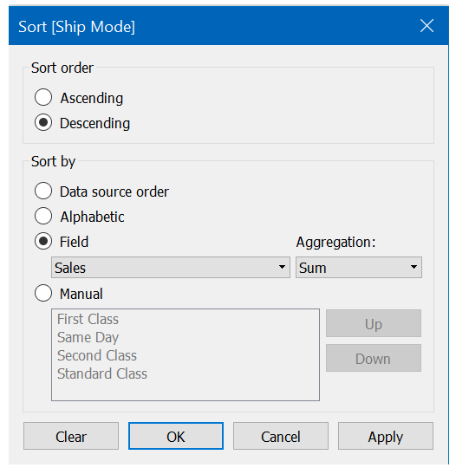

### Step 5:

Create a calculated field for the negative sales and name it anything you like (CF_Negative_Sales, in my case). This will be just –[sales].

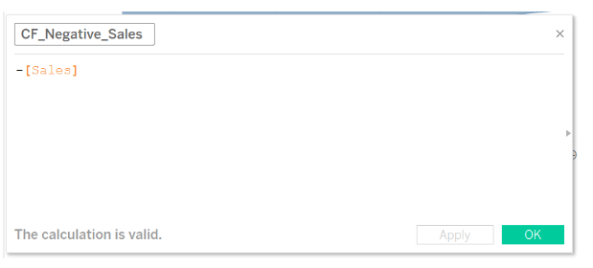

Step 6:

Drag this negative sale calculated field in the column shelf before the sum(sales). This will look like below. Make some adjustments to height, width, and color as needed.

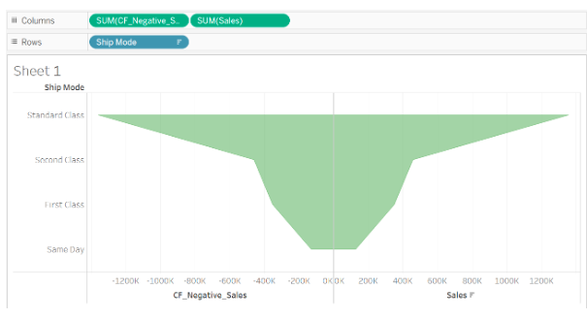

### Step 7:

Now show/hide/change axis and header as required. If you want to show the sales value also, you can enable it from the label. You should also hide the gridlines wherever not required by formatting the worksheet. Once done, the final funnel chart in the tableau will look like below.

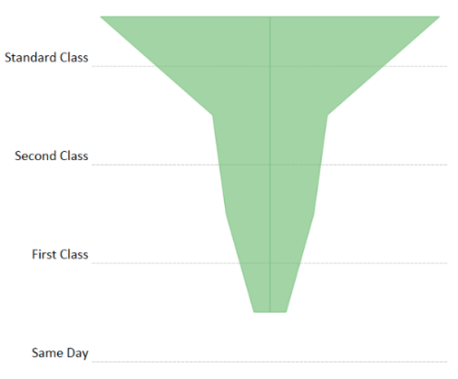

Tableau **Cycle Fields** can be used to cycle the current included dimensions in the current Tableau

sheet. This is very useful when you want to see the effect of different dimension variations.

Tableau Cycle Fields will cycle / rotate dimensions on the current worksheet

1. Open Tableau
2. Then, Select “Excel” from the left “Connect” panel.  (Connect –> To File –> Excel)
3. Finally, Navigate to “Supermarket” transaction Excel file and click on “Open”

After loading dataset ,create a sample visualization. To do that

1. Click on “Sheet”
2. Then, Drag “Marital Status” to the “Rows Shelf”
3. Then, Drag “Gender” to the “Rows Shelf”
4. After that, Drag “Annual Income” to the “Rows Shelf”
5. Finally, Drag “Revenue” to the “Rows Shelf”

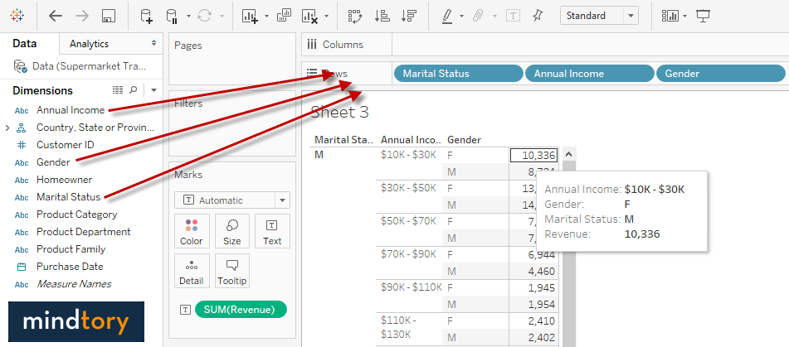

**Note: Cycle Fields will be disabled till you have more than 1 dimension in your visualization. You need at least 2 dimensions inorder to use Cycle fields in Tableau.**

The dimensions order is: Marital Status – Gender – Annual Income. Now, try to select “Cycle Fields” from “Analysis” menu. Note that the order changed to: Annual Income – Gender – Marital Status. Click Again on “Cycle Fields” and the order will change to: Annual Income – Marital status – Gender.

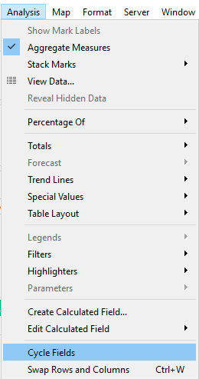

#### We will implement on stacked Bars

In the following example we can see revenue by Marital status, Gender and Annual Income. The gender used to color stacked bars in this case. Let’s assume that we are not sure which dimension is the best one to be used as a color for stack bars. Here cycle Fields comes as a handy feature that allow cycling through available dimensions. In our case you may need to use cycle fields 3 times to see all combinations of the selected dimensions.

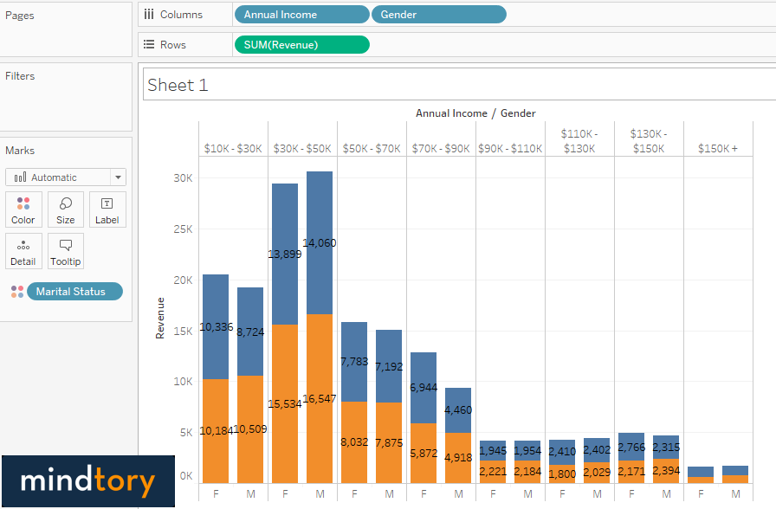

## ****What is a Dual Axis Chart?****

Dual-axis charts are a combination of two charts. It is used to visualize two or more different measures in two different chart types i.e. it depicts the relationship between two variables with different amplitude and scale.

To create a dual-axis chart we must have one date column and two measures.

Let’s understand how to create a Dual Axis Chart in Tableau with an example

## ****Steps to create a Dual Axis Chart****

1.Connect a file (here, we will use Sample SuperStore data)

2.Drag and Drop **Category** into the column shelf

3.Drag and Drop **Profit and Discount** into the row shelf

4.Here, we have two charts present on multiple axes

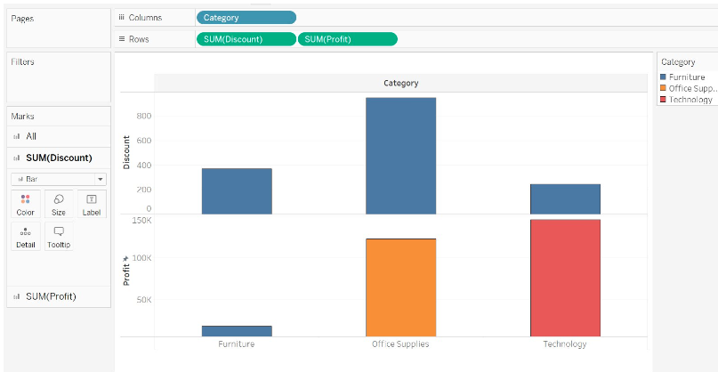

* Right-click on Sum (Profit)
  + Select Dual-axis from the drop-down
  + We get the desired dual-axis chart

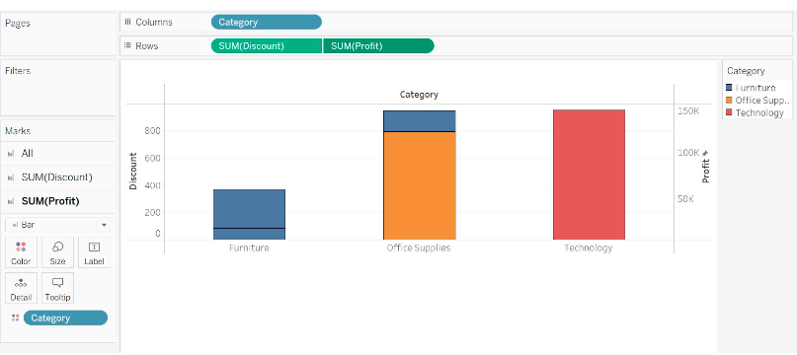

**WHAT IS A CIRCULAR AREA CHART?**

Also known as the Spider or Radar Chart, the Circular Area Chart, this chart shows the different dimensions such as scores and rankings of one item. The further out a point is from the center, the higher it ranks in a category.

**WHEN TO USE A CIRCULAR AREA CHART**

Circular area charts are a great way to compare members of a dimension in a function of several metrics. For example, when you want to buy a smartphone, you can use a radar chart to compare several devices across several metrics like battery life, camera quality, and memory capacity.